Assuming this project will use the database **c3137540_db** (Happy to use anyone else’s if desired) But I’ve already created the tables required in here.

Using port 22 and SSH details below to connect to the remote DB:

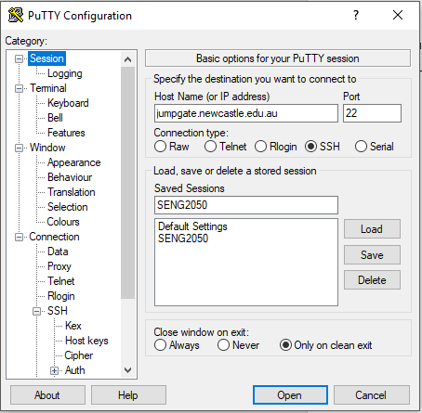

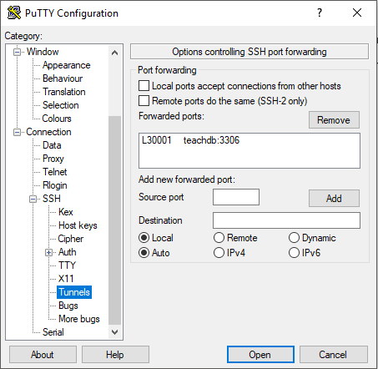

Click Open

Type: mysql -h teachdb -u YourStudentNumber -p

Enter your uni password

Then type: use c313750_db;

Then: 061185

You should be connected to c3137540_db

Test using: SELECT * From User;

The context.xml file already has the connection info saved into it.